JSTL (JSP Standard Tag Library)-

The JSP Standard Tag Library (JSTL) represents a set of tags to simplify the JSP development.

## **Advantage of JSTL**

1. **Fast Developement** JSTL provides many tags that simplifies the JSP.
2. **Code Reusability** We can use the JSTL tags in various pages.
3. **No need to use scriptlet tag** It avoids the use of scriptlet tag.

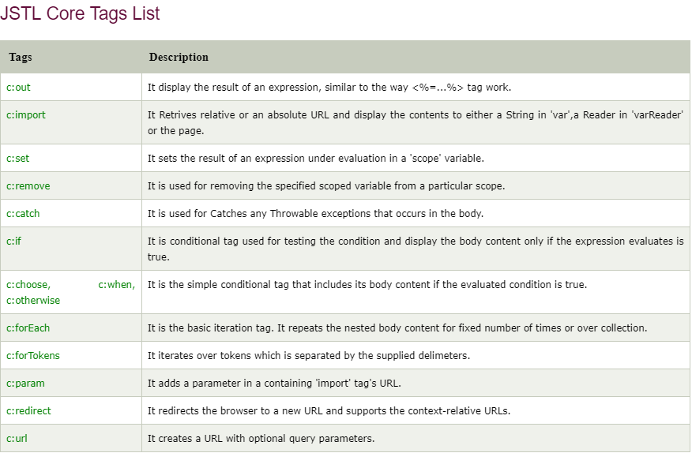

# JSTL Core <c:out> Tag-

The <c:out> tag is similar to JSP expression tag, but it can only be used with expression. It will display the result of an expression, similar to the way < %=...% > work.

The < c:out > tag automatically escape the XML tags. Hence they aren't evaluated as actual tags.

Let's see the simple example of c:out tag:

# 

# JSTL Core <c:import> Tag

The <c:import> is similar to jsp 'include', with an additional feature of including the content of any resource either within server or outside the server.

This tag provides all the functionality of the <include > action and it also allows the inclusion of absolute URLs.

For example: Using an import tag the content from a different FTP server and website can be accessed.

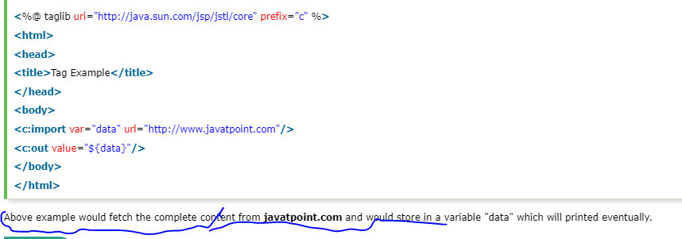

# JSTL Core <c:set> Tag-

It is used to set the result of an expression evaluated in a 'scope'. The <c:set> tag is helpful because it evaluates the expression and use the result to set a value of java.util.Map or JavaBean.

This tag is similar to jsp:setProperty action tag.

Let's see the simple example of <c:set> tag:

# 

# JSTL Core <c:remove> Tag

# It is used for removing the specified variable from a particular scope. This action is not particularly helpful, but it can be used for ensuring that a JSP can also clean up any scope resources.

# 

# JSTL Core <c:catch> Tag-

# 

# JSTL Core <c:if> Tag-

# 

# JSTL Core <c:choose>, <c:when>, <c:otherwise> Tag

The < c:choose > tag is a conditional tag that establish a context for mutually exclusive conditional operations. It works like a Java **switch**statement in which we choose between a numbers of alternatives.

The <c:when > is subtag of <choose > that will include its body if the condition evaluated be 'true'.

The < c:otherwise > is also subtag of < choose > it follows &l;twhen > tags and runs only if all the prior condition evaluated is 'false'.

The c:when and c:otherwise works like if-else statement. But it must be placed inside c:choose tag.